This is my product route where you can see list of all products through popstman or Thunderclient with /get request on /products

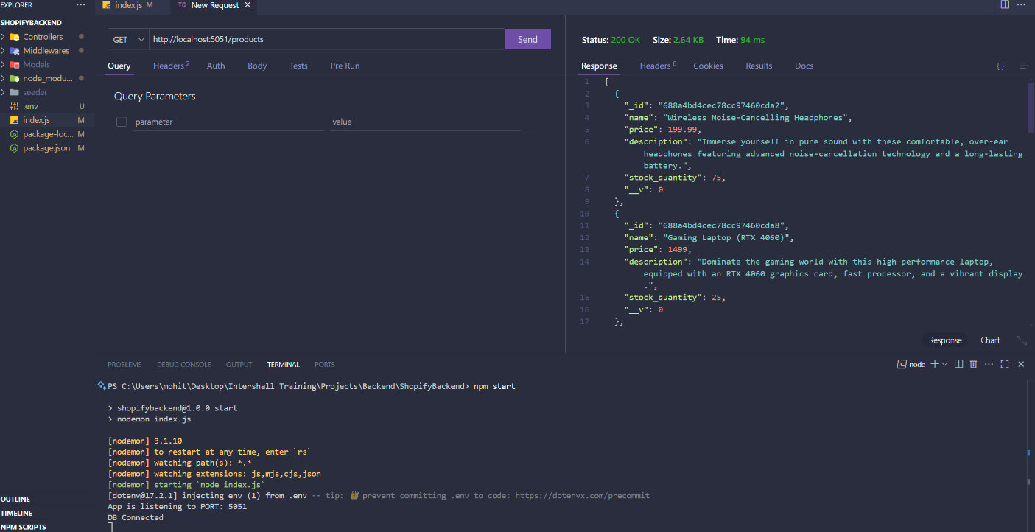

This route is to view single product item /get request on /products/:id.

You can get product id from above product list

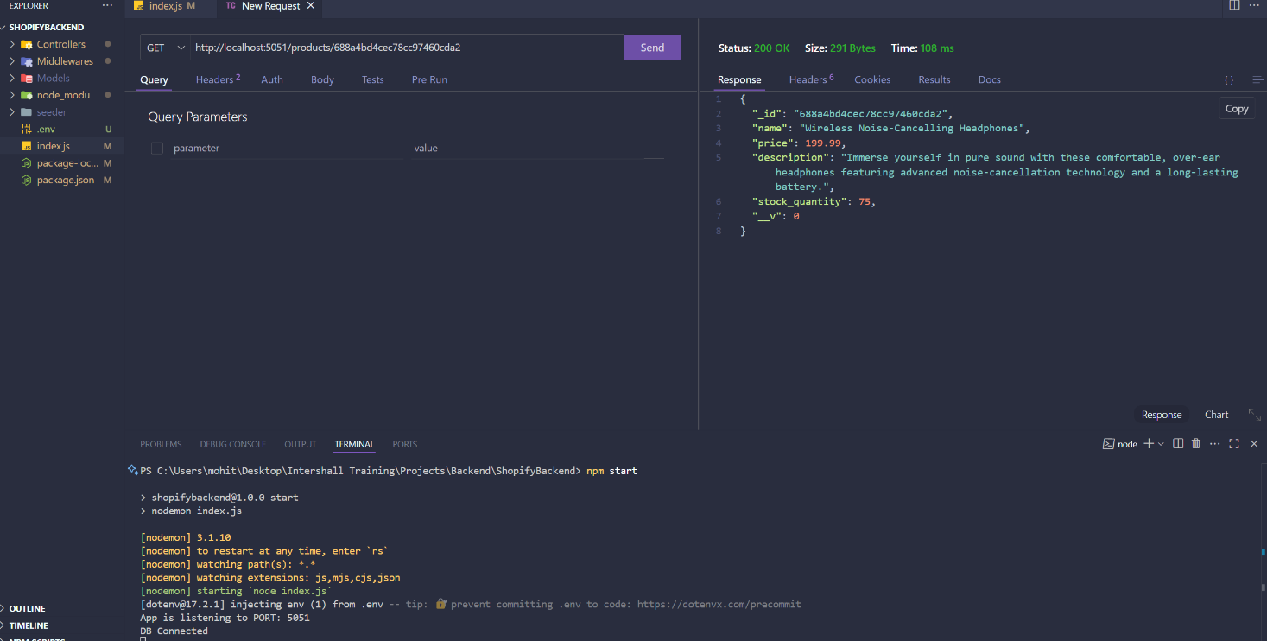

This is my /post request to register a new user. You can use /register route with passing a json data with “username” & “password” on body

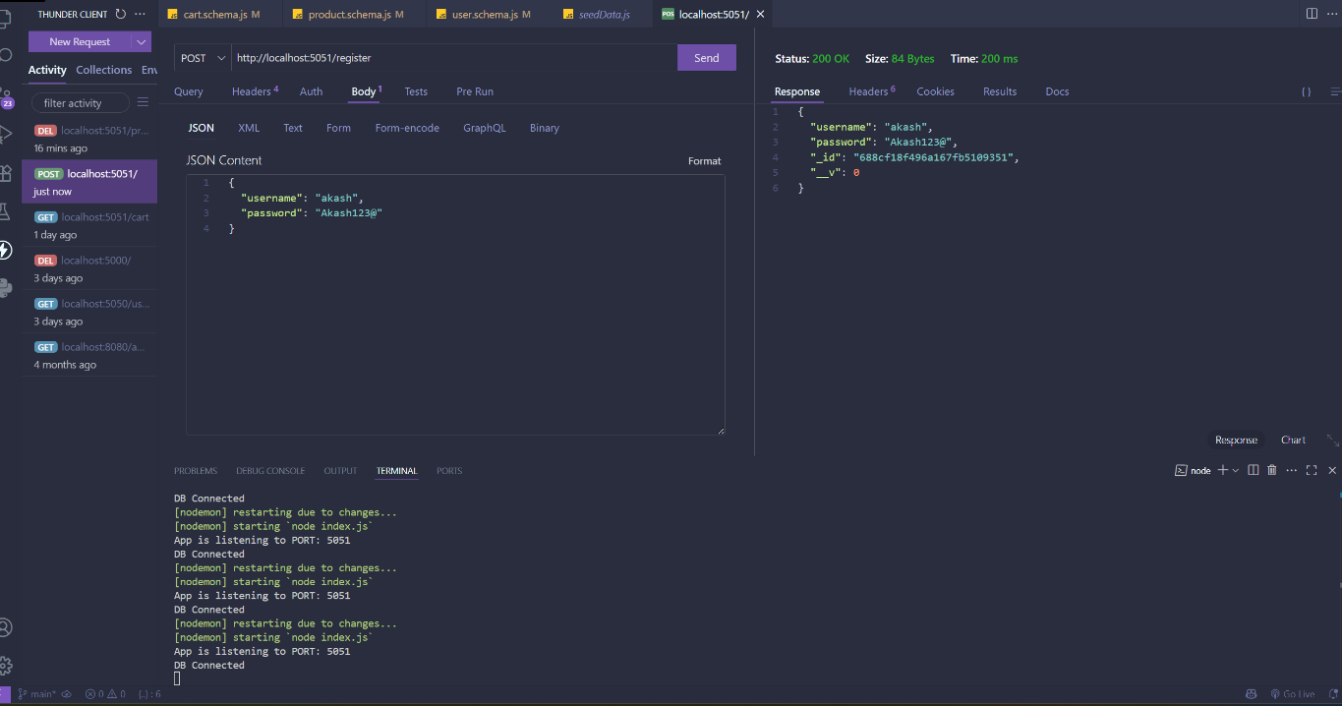

This is my /post request on /login route. You have to enter both “username” & “password” as json data on body which will generate you a token. Copy this token and use it on header to access all the authorized routes 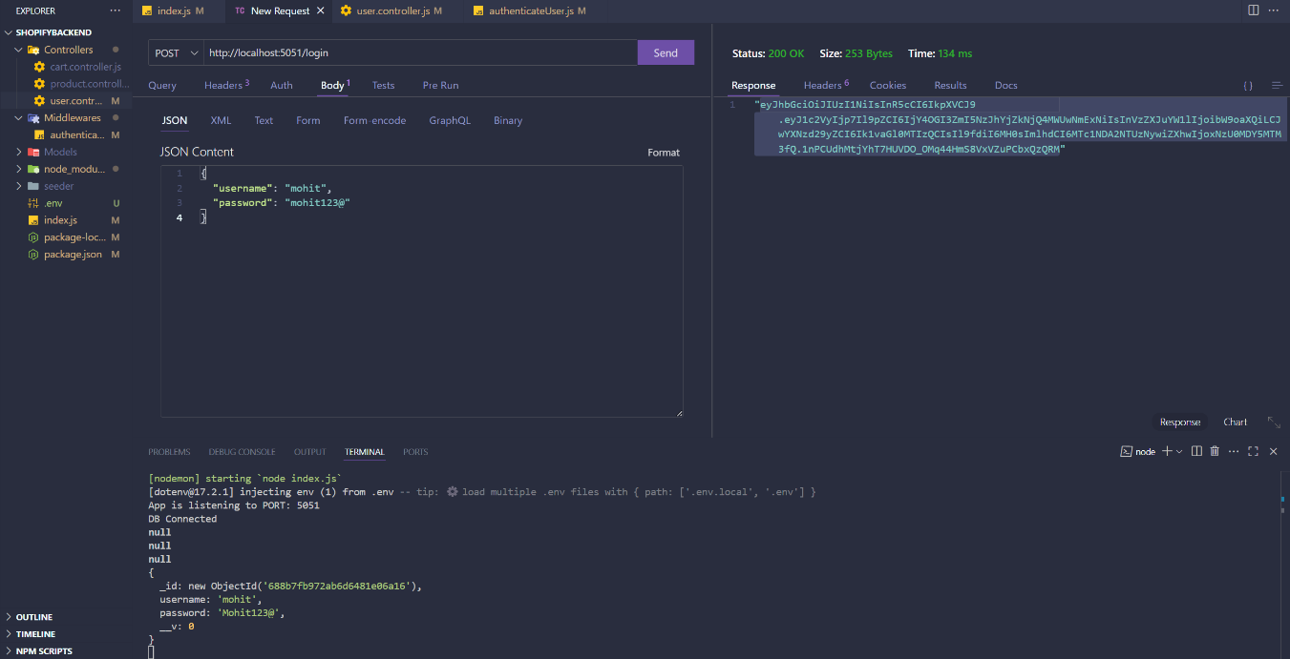

This is my cart route where you can see list of all cart items with /get request on /cart. You have to paste the required token in header with JWT to access this authorized route

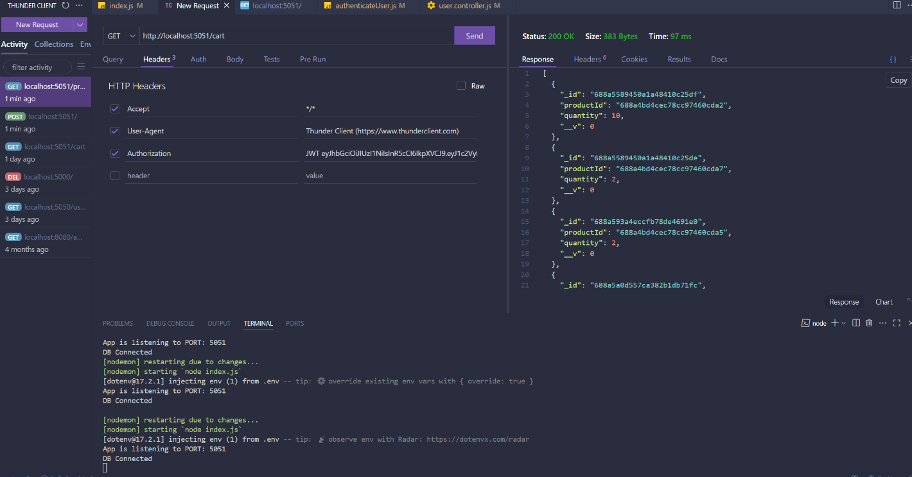

This /cart/add route is to add product in your cart. You have to send /post request with productId as well as quantity to add your selected product into cart

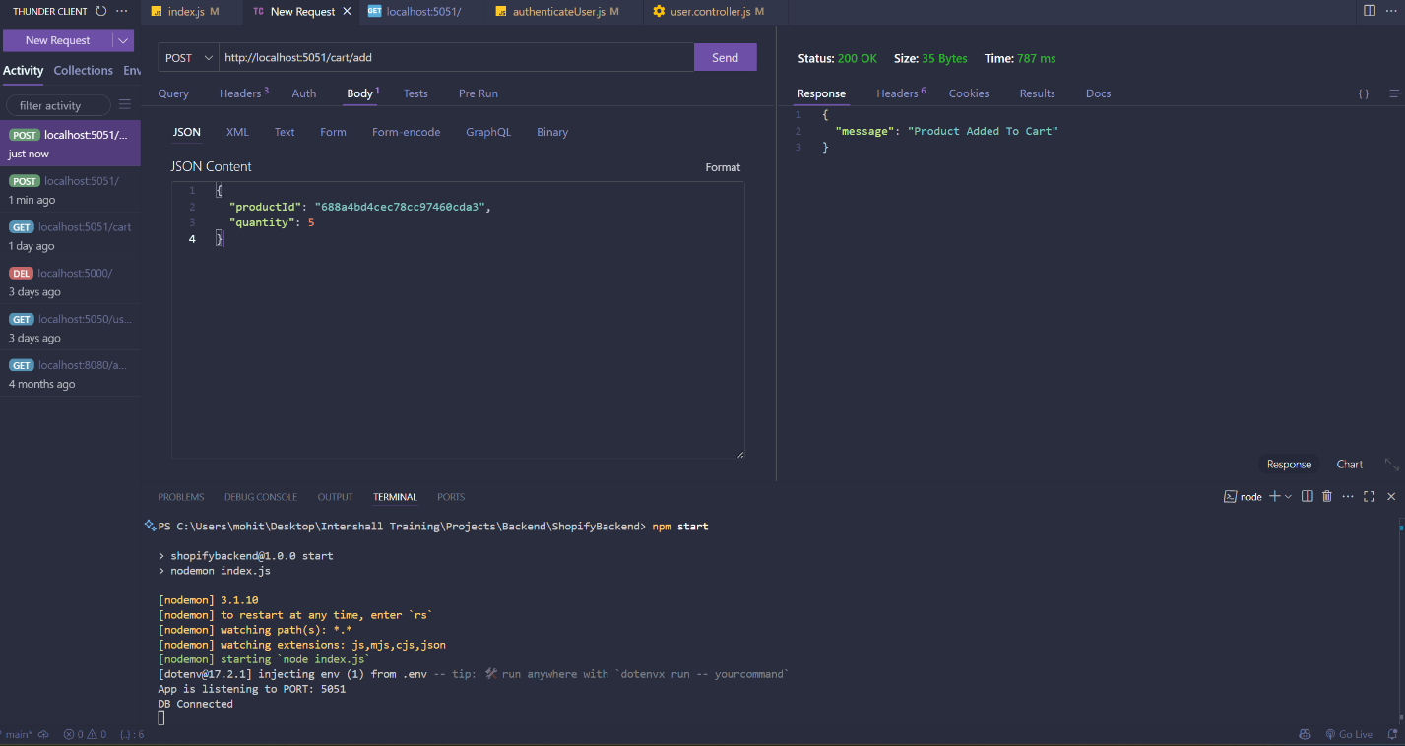

This /cart/:id (Id should be cart ID) route is to update you cart items quantity with /put request. You have to provide quanity as json data in body

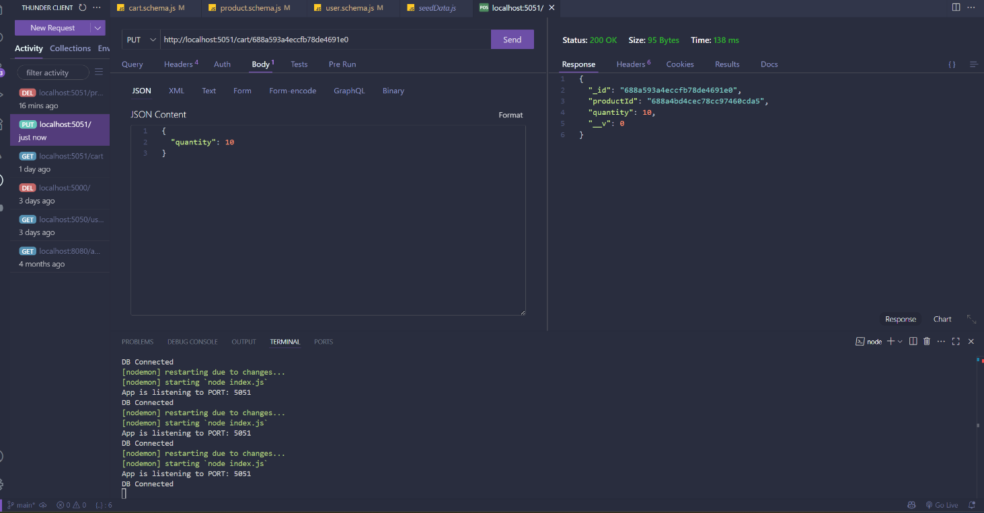

If you send /delete request on /cart/:id (Id should be cart ID) route It will delete that cart item

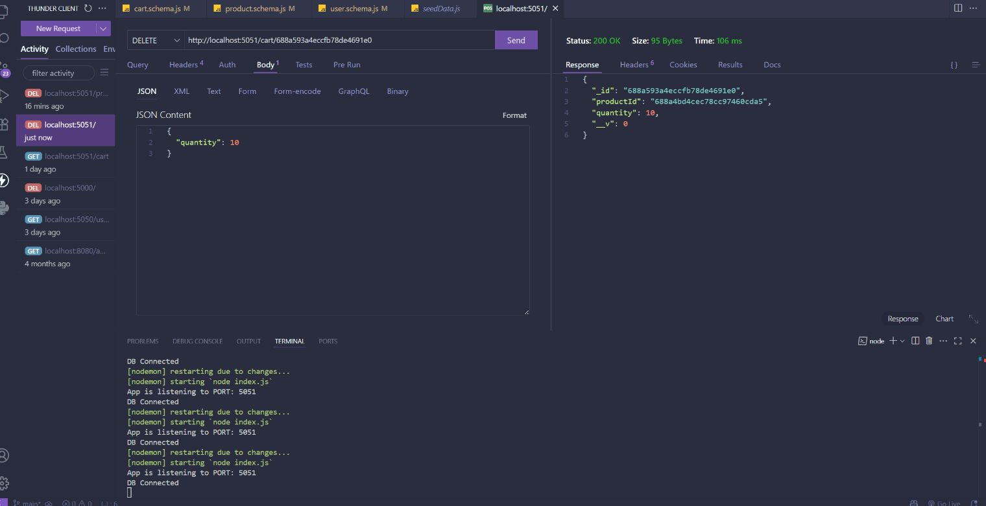

Below are my Product, User and Cart Collection from my DataBase that was created during Project

